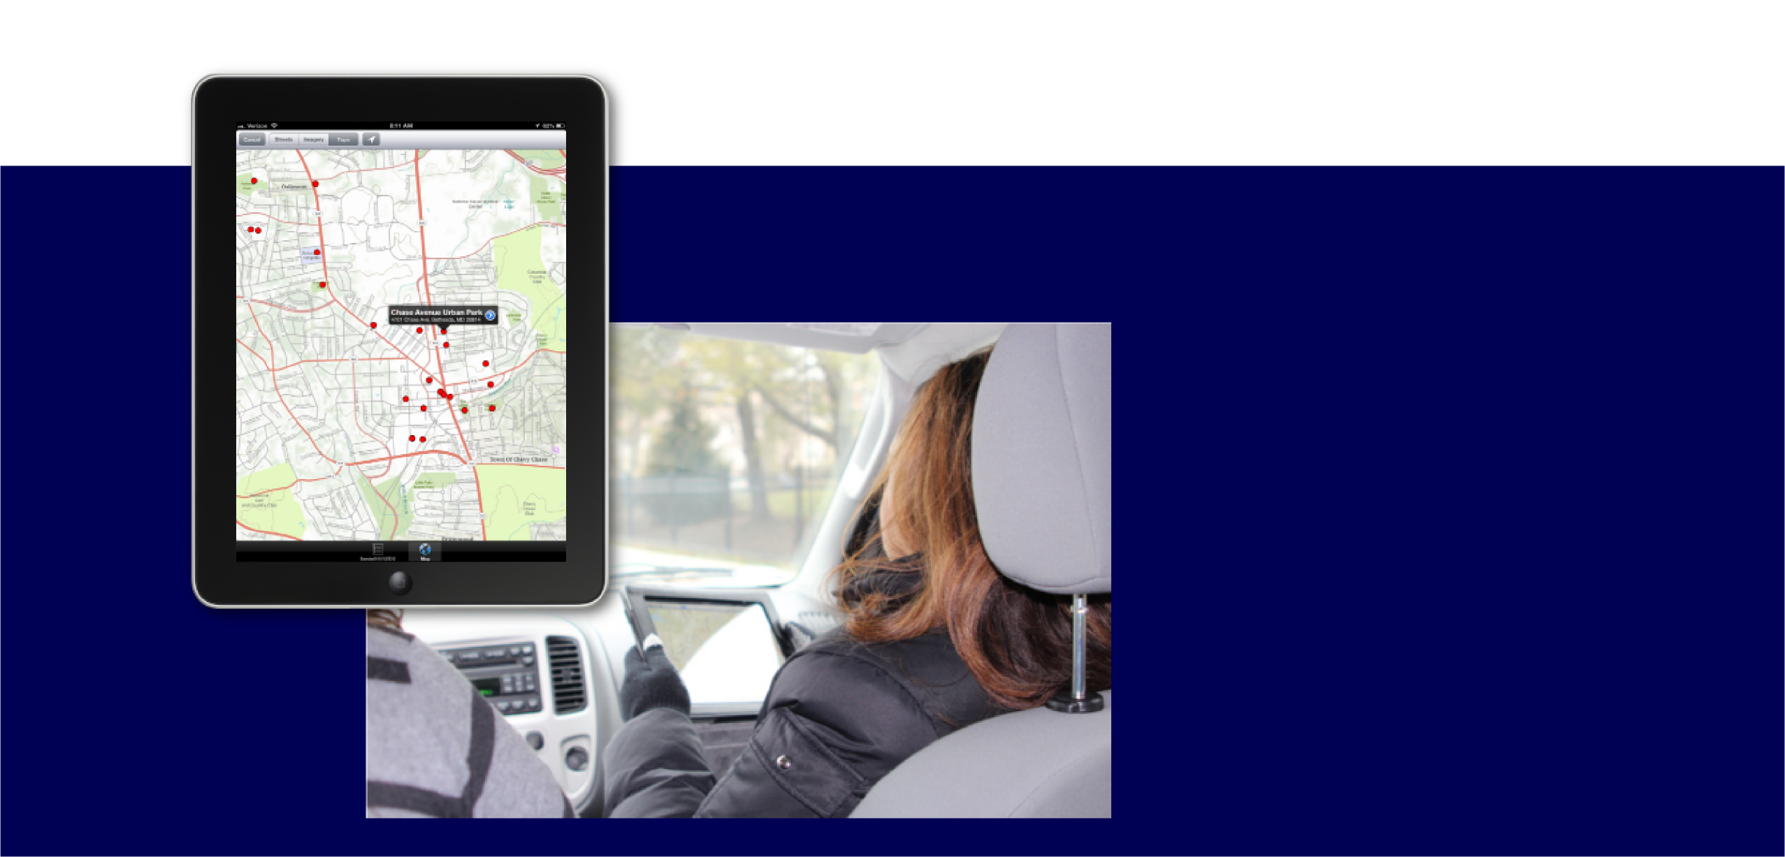
Disaster Management Standard Operating Procedures

Date: ???

Version 9.0

Prepared for:

Emergency Management
<<Address>>


Table of Contents
Table of Contents 2
1. Purpose 4
2.0 Definitions and Explanations 4
3.0 Concept of Operations 5
3.1. Pre-Disaster Planning and Data Gathering 5
3.1.1 Standards and Forms 5
3.1.2 Identify Personnel 5

3.1.2.1 Prerequisites for personnel to participate on a Damage Assessment Team 5

3.1.2.2 Setting up New Users in Crisis Track 5
3.1.3 Preload Local Data 7

3.1.3.1 Format for GIS or Tax Assessment Data 7

3.1.3.2 Loading Force Labor 7

3.1.4 Preconfigured Damage Assessment Teams 11

3.1.5 Preconfigured Damage Assessment Tasks 12

3.1.6 Jurisdictions 14
3.1.7 Training and Exercises 14
3.2 Organizational Structure 14
3.3 Damage Assessment Methodology 14
3.3.1 Damage Assessment Activation 14
3.3.2 Identify the Incident 14
3.3.3 Defining an Area of Concern 16
3.3.4 Assigning Personnel and Equipment to Damage Assessment Teams 17
3.3.5 Creating Tasks 18
3.3.6 Adding Preconfigured Tasks 20
3.3.7 Assigning Specific Structures to Tasks 21
3.3.8 Conducting Damage Assessment Field Operations 24

3.3.8.1 Damage Assessment Team Pre-Deployment Briefing 24

3.3.8.2 Field Data Collection 24

3.3.8.2.7 Switching Forms. 29

3.3.8.2.12 Conducting a Damage Assessment with Limited or No Internet Connectivity 31

3.3.8.3 Conducting Damage Assessments from the Crisis Track Console App 33

3.3.8.4 Initial Damage Reports and Citizen Self Reporting 34

3.3.9 Monitoring Tasks and Teams 35

3.3.10 Damage Assessment Team Post Deployment Briefing 38

3.3.11 Reporting 38
3.3.12 Subsequent Support Activities 39
3.4 Maintenance of Procedures, Systems and Capabilities 40
Appendix A: Organizational Chart for Damage Assessment 41
Appendix B: List of Damage Assessment Teams 42
Appendix C: Roster of Trained Damage Assessment Personnel 43
Appendix D: Equipment and Supplies for a Damage Assessment Team 44
Appendix E: Quick Reference Guide for Crisis Track Structural Assessments 45
Appendix F: Damage Category Reference Guide 46
Appendix G: Standard Forms Used to Conduct Damage Assessment Operations 48

Purpose

The purpose of this document is to outline the steps to conduct disaster management operations before an event occurs, immediately following an event, and after the major damage assessment field operations are complete. The steps will provide the jurisdiction with a detailed process for conducting a damage assessment including those steps to use the Crisis Track Damage Assessment software solution. This document is intended to supplement the <your jurisdiction’s> Emergency Operations Plan.

Definitions and Explanations

  - Damage Assessment

Damage Assessment is an information gathering activity to determine the severity and magnitude of an incident, to establish priorities for recovery, and to assess resource needs.

  - Rapid Damage Assessment

A Rapid Damage Assessment is a quick and often incomplete report of damage to a structure.

  - Damage Assessment Officer

<your jurisdiction’s> Damage Assessment Officer is responsible for supervising the damage assessment mission as well as managing the damage assessment processes. During an event, the Damage Assessment Officer reports to …

  - Damage Assessment Teams

Damage Assessment Teams conduct visual inspections of infrastructure to determine the extent of damage from an incident. The Teams are comprised of individuals trained in damage assessment methods and procedures. All Damage Assessment Team members will report to the Damage Assessment Team Leader.

  - Damage Assessment Team Leaders

Each Damage Assessment Team will have an assigned Damage Assessment Team Leader. The Damage Assessment Team Leader is responsible for the Damage Assessment Team’s assignments, communications, and safety. The Damage Assessment Team Leader reports to the Damage Assessment Officer.

  - Crisis Track Disaster Management Software

Crisis Track Disaster Management is the mobile software solution purchased by <your jurisdiction> to collect, track, and report disaster operations information.

3.0 Concept of Operations

3.1. Pre-Disaster Planning and Data Gathering

3.1.1 Standards and Forms

<your jurisdiction’s> has adopted a version FEMA Public Assistance Form, FEMA Individual Assistance Form, and SBA Commercial Form as outputs when conducting damage assessment operations (Appendix G). Crisis Track configured the Crisis Track Mobile Application with information required to complete these forms.

3.1.2 Identify Personnel

The Damage Assessment Officer will identify a pool of potential personnel who are willing and able to conduct a damage assessment.

3.1.2.1 Prerequisites for personnel to participate on a Damage Assessment Team

Training…
Capability…

3.1.2.2 Setting up New Users in Crisis Track

Setting up credentials for a new user into your account requires Crisis Track Administrator privileges.
To set up a new user:

- Log into the Crisis Track Console by clicking https://www.crisistrack.com/console/

- Click on Select beside of “Administrative Functions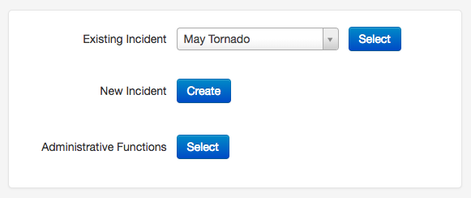

- Next click on the Users button 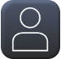

- Click on New in the upper left-hand corner and add the information for the new user. Only User ID, Password, First Name, Last Name, Email, and Role are required information. Select the “Send email to user with login info” box if you would like the user to receive their log in information in an email.

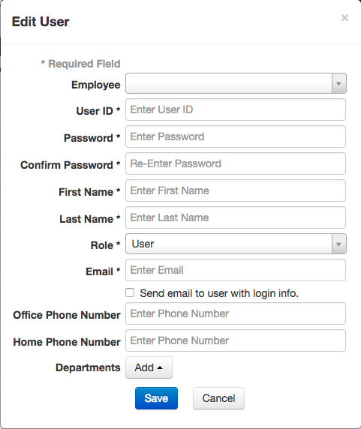

User roles are as follows:
- The Admin role will grant administrative access to Crisis Track and provide rights to the Admin Console. This role can create incidents; manage resources; create users; create preconfigured team and tasks; create, edit and delete incident specific tasks; create, edit, delete areas of concern. Given that this role can create users and edit datasets, these rights should be granted only after careful consideration.
- The Admin (No Payroll) grants administrative access without allowing the user to see employee pay information.
- The Commander role is a User Role with the ability to create incidents. This role can create incidents; create, edit and delete incident specific tasks; create, edit, delete areas of concern.
- The User role will have field access to Crisis Track. This role can edit and delete incident specific tasks; create, edit, delete areas of concern. They will not be able to edit facilities, equipment, employees, users or incidents.
- The Viewer role can view entries and incident operations.
Selecting the Employee from the drop-down will link the employee’s name to the user name.

3.1.3 Preload Local Data

Crisis Track uses your jurisdiction’s GIS data to map a point of every structure with its tax-assessed value. It’s what streamlines the damage assessment process and calculates disaster damage costs in real time. The Crisis Track subscription provides you with technical support to import the GIS layers of your infrastructure locations with tax-assessed values. Please contact support@crisistrack.com for assistance in loading your structure data.

3.1.3.1 Format for GIS or Tax Assessment Data
The end goal is to get a feature class as points with the following attributes:
- Owner Name
- Street Address
- Phone Number (this is optional)
- Property Ownership Type (such as Gov't, Church, School, Business, Residential)
- Improved Value (or Land Value and Total Value)

This dataset will be refreshed on an annual basis.

3.1.3.2 Loading Force Labor
Crisis Track can help jurisdictions track and account for a Team’s time. If the Jurisdiction chooses to use the Employee time tracking, the Crisis Track system will need a list of the Jurisdiction’s Employees and their pay rates. Volunteers may also be added. This can be done manually or by bulk upload. Here’s how to manually add employees:
- Log into Crisis Track by clicking https://www.crisistrack.com/console/
- Click Select beside of “Administrative Functions.”
- Select the Employees Icon 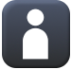
- Select Add then New in the upper left-hand corner of the page.
- Fill in the following information about the employee and their pay:
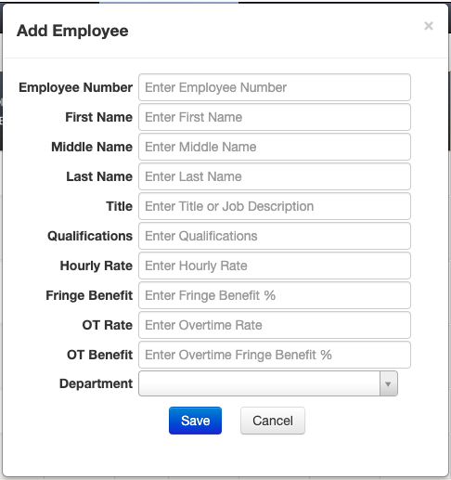
- Click Save
To bulk upload employees, follow these instructions:
- Log into Crisis Track by clicking https://www.crisistrack.com/console/
- Click Select beside of “Administrative Functions.”
- Select the Employees Icon
- Select Add then Upload CSV or XLS in the upper left-hand corner of the page.
- You will then be given the option to download either an XLS template or a CSV template. Select your preferred option and the template will automatically download to your computer.
- When you open the file, you will see an already formatted spreadsheet with the required fields. Fill it out and save it to your computer.
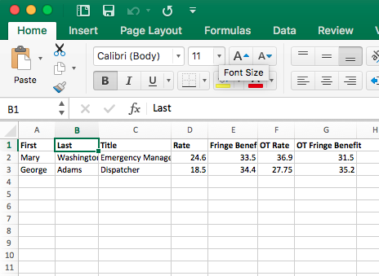
- Back on the Crisis Track webpage where you downloaded the template, click Select File and find the file you just created. Open it and then click Save Employees.
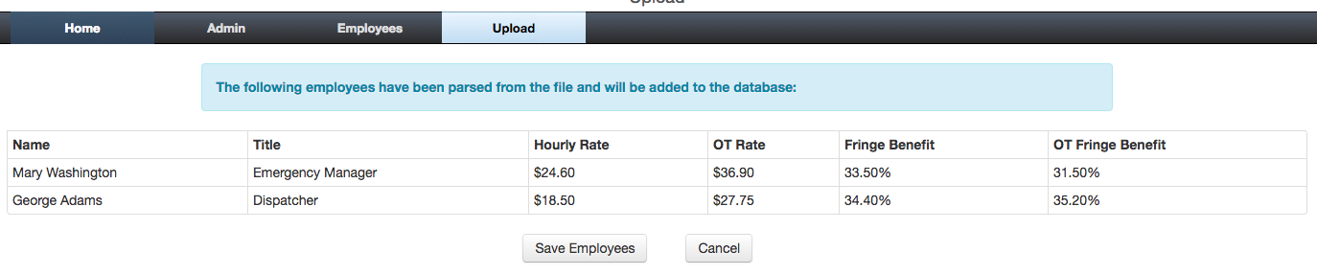
- If an employee name or employee identifier is found, then the record will be replaced instead of added.
3.1.3.3 Loading Equipment Inventories
Crisis Track can help jurisdictions track and account for Equipment use and costs. This can be done manually or by bulk upload. To manually upload, follow these instruction:
- Log into Crisis Track by clicking https://www.crisistrack.com/console/
- Click Select beside of “Administrative Functions.”
- Select the “Equipment Inventory” Icon 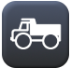
- Click Add then New. When the “Add Equipment” box appears, click Search Cost Codes.
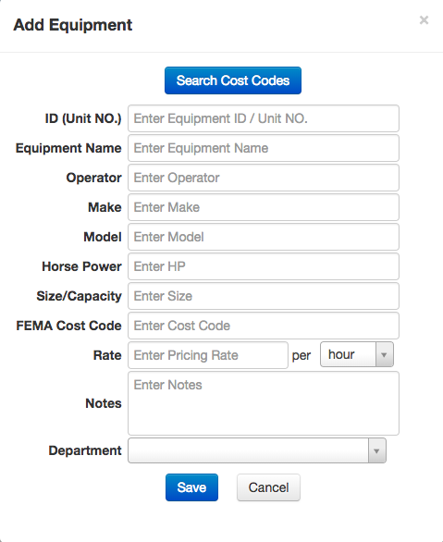
- Use the filter box to find FEMA equipment cost codes. Once found, click Select on the right-hand side.
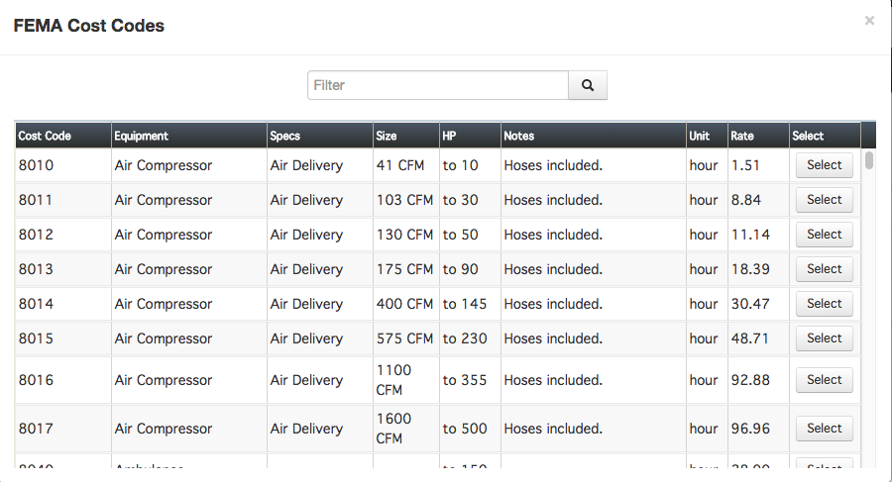
- Fill in the remaining information in the “Add Equipment” box.
- Click Save.
To bulk upload equipment, follow these directions:
- Log into Crisis Track by clicking https://www.crisistrack.com/console/
- Click Select beside of “Administrative Functions.”
- Select the “Equipment Inventory” Icon
- Click Add then Upload CSV or XLS.
- You will then be given the option to download either an XLS template or a CSV template. Select your preferred option and the template will automatically download to your computer.
- When you open the file, you will see an already formatted spread sheet with the required fields. Fill it out and save it to your computer.
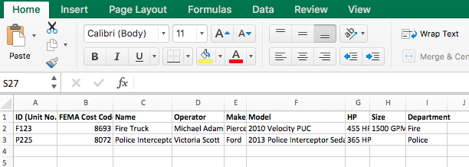
- Back on the Crisis Track webpage where you downloaded the template, click Select File and find the file you just created. Open it and then click Save Equipment.
- If an equipment record is found with a matching name and ID, then the record will be replaced instead of added.

3.1.4 Preconfigured Damage Assessment Teams

To streamline deployment, Crisis Track allows you to setup preconfigured Damage Assessment Teams that can be used for all events.

Teams assigned in the Administration Console will be available in any Incident created with Crisis Track. You can create Teams with only employees and/or only equipment, then augment the Teams when an incident occurs.
To create a new team, click on the Teams icon in the Admin Console: 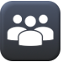
Click on New, enter a Team Name and any notes about the team. Next add employees and equipment by selecting from the drop-down lists specific to your organization. You can also add new employees and equipment at this time.
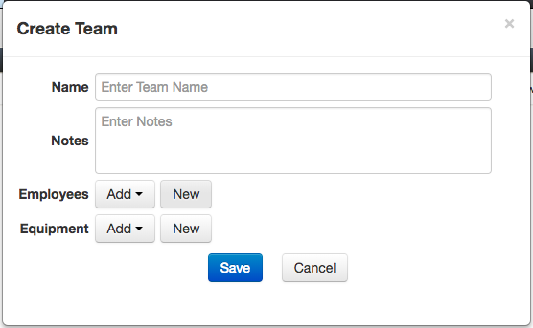

Then click Save.

3.1.5 Preconfigured Damage Assessment Tasks

To help plan for your incidents, Crisis Track allows you to set up Preconfigured Tasks. Similar to Preconfigured Teams, the Preconfigured Tasks created in the Admin Console will be available for any Incident in your Crisis Track Account.
To create a new preconfigured task, click on the Tasks icon in the Admin Console: 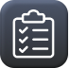
Click on New and enter a Task Name, Description, and Special Instructions (the latter two items are optional). Next select the time charging category.
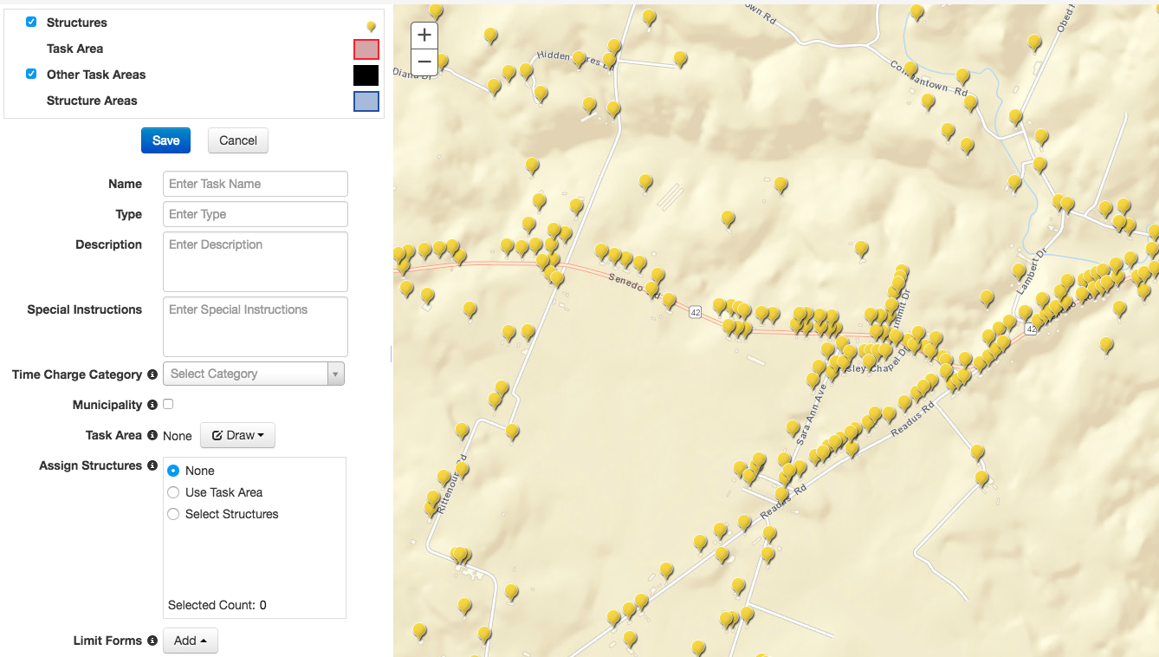

Next, you may create a Task Area by clicking “Draw” and selecting either “Freehand Line,” “Freehand Polygon,” “Polygon,” “Line,” or “Rectangle.” You can then select “Use Task Area” beside of “Assign Structures” to assign structures to that task area. You may also draw a separate area using “Select Structures” to assign structures.
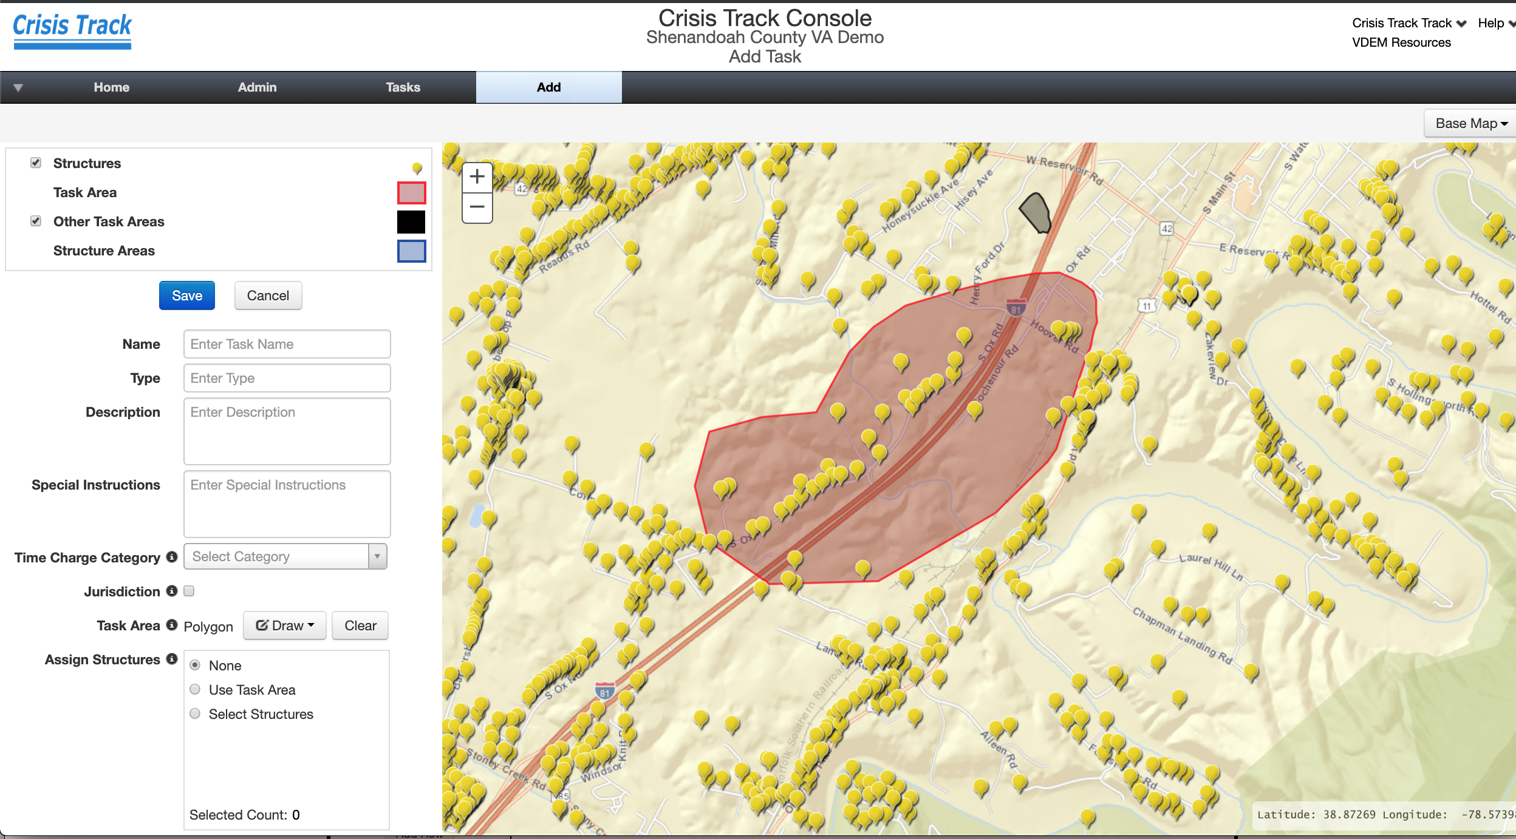
Then click Save.

3.1.6 Jurisdictions

Crisis Track allows municipalities or other organizations within a county to have a focused view of their specific data called a Jurisdiction. Jurisdictions can set their own teams and tasks using personnel and equipment lists that are specific and only visible to users of that Jurisdiction’s view. Disaster costs roll up to the county’s charts and reports and a jurisdiction’s operations are visible on the county’s Operations View.
To set up municipal views in your account, contact support@crisistrack.com.
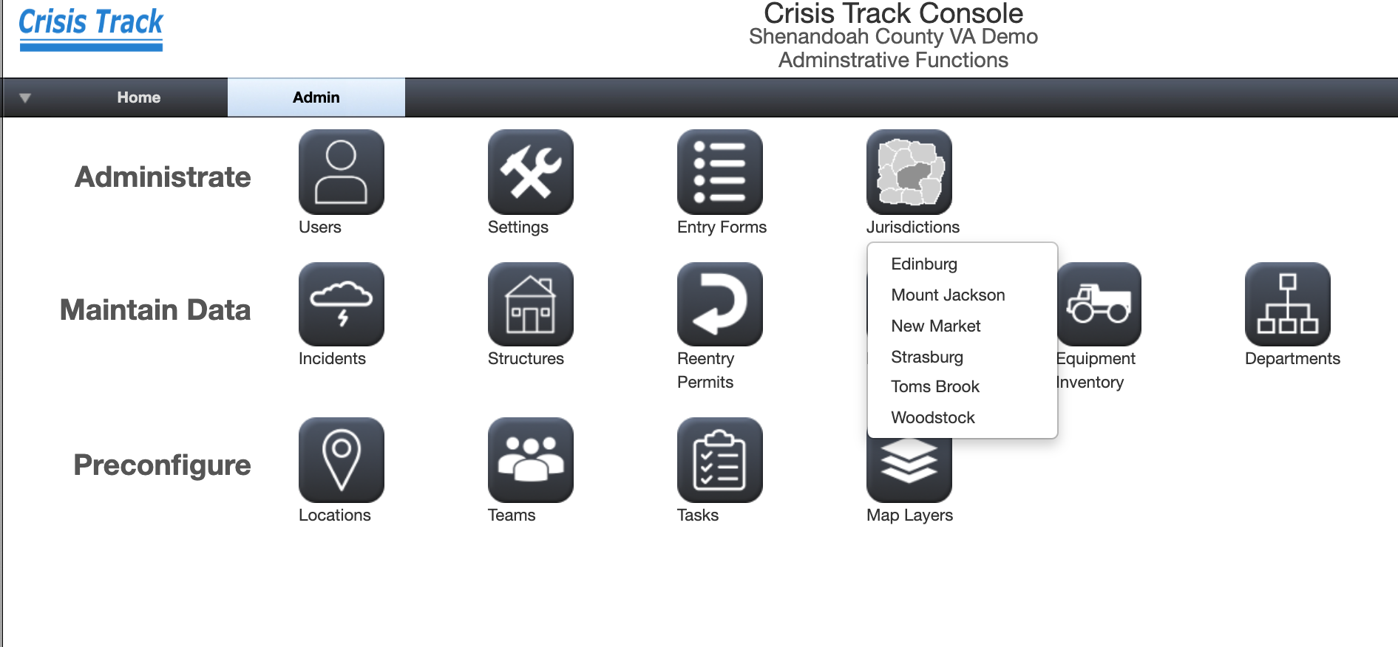

3.1.7 Training and Exercises

The procedures of this document will be exercised ?? each year.

3.2 Organizational Structure

Appendix A provides an overview of the organizational structure of the Damage Assessment Operations

3.3 Damage Assessment Methodology

3.3.1 Damage Assessment Activation

A Damage Assessment mission will be activated when <add decision process for activating a damage assessment operation>

3.3.2 Identify the Incident

Once a damage assessment operation is activated, the Damage Assessment Officer will add a new incident into Crisis Track.

Note: You must be a Crisis Track Administrator or Commander role to complete these steps.
To create a new incident:

- Log into the Crisis Track Console by clicking https://www.crisistrack.com/console/

- Click on either “New Incident” or “Administrative Functions.”

- If clicking “Administrative Functions”, click “Incidents” 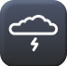 and “New”

- Complete the following form for a new Incident and click Save:

Name: Name of the Incident
Status: Active or Closed. Only Active incidents can be selected by the Crisis Track applications.
Type: Type of Incident based on FEMA’s list of types
Date: Start date of the Incident
Description: A description of the incident
Population: Population of your jurisdiction. This will be prepopulated from the population value on the Configuration window in the Administration module.
FEMA per Capita Factor: FEMA’s countywide impact indicator. The default value is the current year’s value.
Default Team/Default Task: These items will create a default team and default task to speed up data collection.

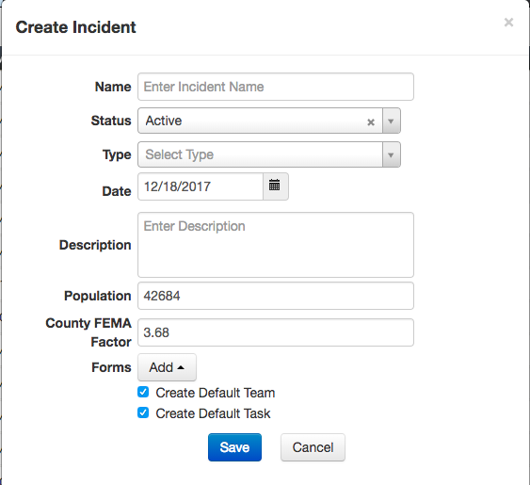

3.3.3 Defining an Area of Concern
On the Incident home page, the footprint module allows users to create and manage an incident’s Area of Concern, which delineates the affected area of a given event. This boundary will be on all console and mobile application maps.

To create an Area of Concern manually:

Select your incident and click on the Footprints icon.

- Click Add, then select Area of Concern. A form will appear on the left hand side.
- Fill out the Name of the Area of Concern and a description, if necessary.
- Select draw, and freehand polygon. After you draw the Area of Concern, you can then change the color.
- Click Save and you will see the newly drawn Area of Concern on your map.

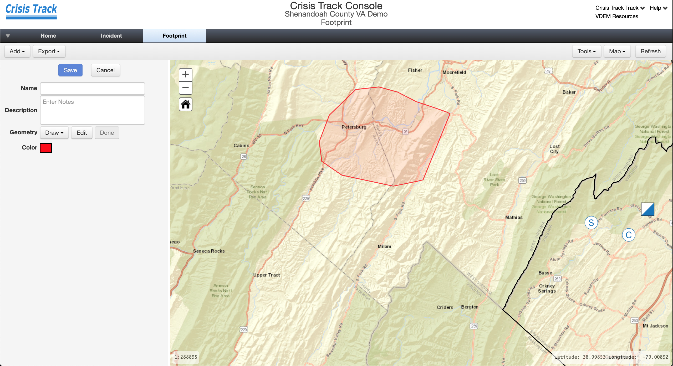

You can also upload an Esri shapefile with simple features to define the Area of Concern.

To upload an Area of Concern:

- Click Add, then select Upload AOC shapefile
- Enter the ESPG number for your coordinate reference
- Click Upload shapefile

Finally, you can export your Area of Concern to an Esri Shapefile by clicking on Export and Shapefile.

3.3.4 Assigning Personnel and Equipment to Damage Assessment Teams

A Team is a group of personnel and equipment assigned to do a specific activity. The Employee and Equipment lists from which Teams draw were added as part of Section 3.1.3.2 Loading Force Labor and Equipment Inventories.

To add or create a new team to an incident:

- Log into the Crisis Track Console by clicking:
https://www.crisistrack.com/console/
- Select the Disaster or Incident that you are working with.
- Then click on the Teams icon in the Incident View:
- To add a Team from the pre-configured teams (created in Section 3.1.5), click Add and then Preconfigured Team
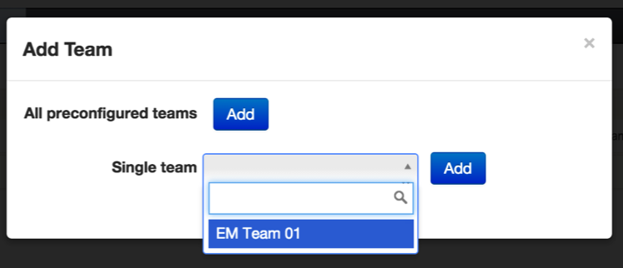
Here, you can add a single Team from a drop-down list or add all pre-configured teams to the incident.
- To create a new team click on New and enter a Team Name and Description (optional). Next add employees and equipment by selecting from the drop-down lists specific to your organization. The text box above the drop-down lists allow you to filter by name. You may also click on “New” to add new employees or equipment. These forms will be added to your Employee and Equipment tables discussed in Section 3.1.3.2
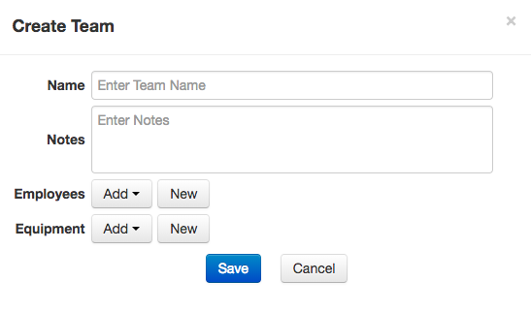
- Click Save.
This Team name will now appear when users login and select their teams.

3.3.5 Creating Tasks

A Task is an activity that you assign to a Team, such as structural damage assessments for the damage assessment team or bridge inspections for the roads departments.

To create a new Task to an incident:

- Log into the Crisis Track Console by clicking:
https://www.crisistrack.com/console/
- Select the Disaster or Incident that you are working with.
- Then click on the Tasks icon in the Incident View:
- To create a new Task click on Add and then New Task. Enter a Task Name and Type (optional).
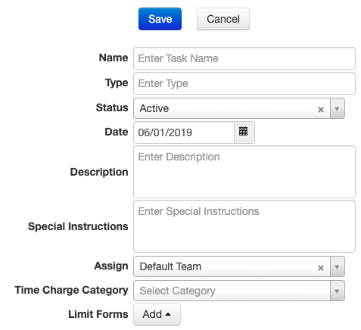
- Status is used to control the tasks that your Damage Assessment Teams see on the Crisis Track mobile application. Tasks with statuses of Request, Assigned, or Hold will be visible on the mobile application. Tasks with Closed will not be visible on the mobile application.
- Description and Special Instructions (optional) are used to populate ICS 204 forms. This information will be visible on the mobile application.
- Assigning the Task to a Team will make the Task only visible to the Team it is assigned. A Task can be assigned to only one Team.
- Time Charge Category (optional) will populate the hours and costs to the FEMA Work Categories on FEMA specific output forms such as the PA Damage Inventory spreadsheet and Project Worksheet.
- You can limit the forms available for a specific task by adding the form to the Limit Forms list. Here are the types of forms available for DM and DA accounts:
Form | Description | DM | DA
Public | Public building damage assessment
Residential | Residential building damage assessment
Commercial | Commercial building damage assessment
Road Damage | Road damage assessments
Bridge/Culvert/Ditch Damage | Bridge, culvert, or ditch damage assessment
Lighting/Sign Damage | Lighting or sign damage assessment
Initial Damage Report | Windshield survey form for damage assessments
Citizen Self Reporting | This form will allow the Citizen Self Reporting URL to be active for this incident (see Section 3.3.5.4).
Road Closure | Tracks road closures and resulting debris.
Debris Estimation | For estimating debris not on the road right of way.
Load Ticket | Used for debris monitoring operations.
Disposal Ticket | Used for debris monitoring operations
Unit Rate Ticket | Used for debris monitoring operations
EM Request | For tracking non-emergency requests in the EOC
ATC 20 | Rapid Evaluation Safety Assessment Form for buildings in earthquakes.
ATC 45 | Rapid Evaluation Safety Assessment Form for buildings in flood or wind events.
Evacuations | Used to keep track of residents who go to shelters and who shelters in place.
Truck Certification
Water Infrastructure

3.3.6 Adding Preconfigured Tasks

Preconfigured Tasks are tasks setup in the Admin Console that can be added to any incident (see Section 3.1.6.).

To add a Preconfigured Task to an Incident:

- Log into the Crisis Track Console by clicking:
https://www.crisistrack.com/console/
- Select the Disaster or Incident that you are working with.
- Then click on the Tasks icon in the Incident View:
- Click on Add and then Preconfigured Tasks and a map showing the Preconfigure Tasks will appear.
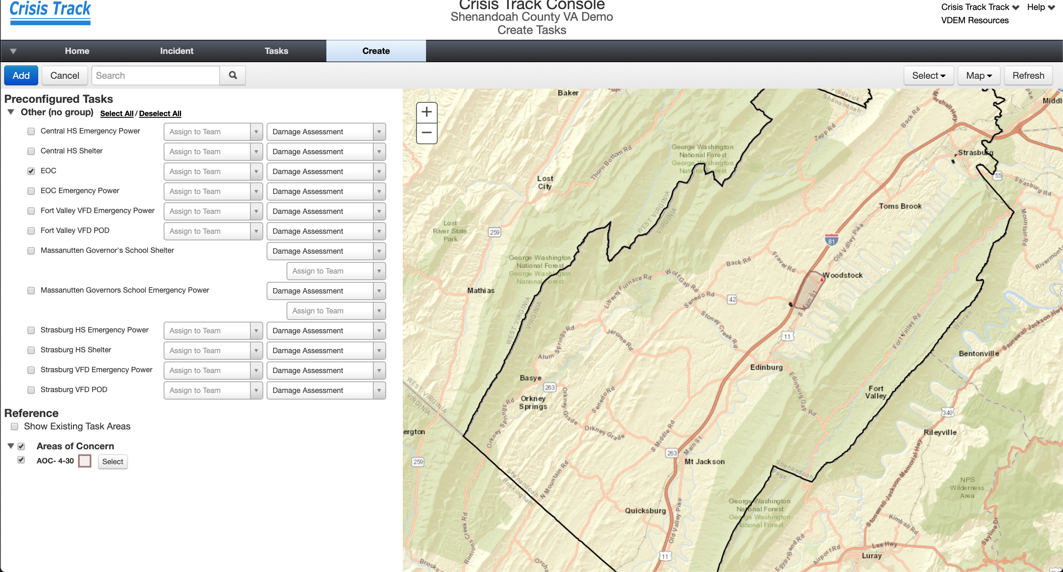
- Here you can either select from the list or from the map (click on Select for draw tools) the Preconfigured Tasks you would like to add to the Incident.

- You can also use an Area of Concern (see Section 3.3.5.4) to select a set of Preconfigured Tasks that intersect the AOC boundary.

3.3.7 Assigning Specific Structures to Tasks

The Damage Assessment Officer will receive initial damage reports from first responders or from the Public. These reports will determine the need to conduct a Damage Assessment Operation and serve as the basis for assigning areas of responsibility to the damage assessment teams.

Crisis Track uses local data – loaded in Section 3.1.3.1 – to assign structures and prepopulate the damage assessment forms. By using local data to assign structures to tasks, these structures will appear on the Damage Assessment Team’s field units as assignments. It’s how Crisis Track can help ensure that you do not have overlapping assignments and can help you limit assessments to only those areas that are reporting damage.

In addition, the Ownership Type – Public, Residential, or Commercial – relates the structure to the corresponding disaster assistant grant category – Public Assistance, Individual Assistance, or Small Business Administration Disaster Loans. This streamlines the damage assessment process by providing the correct form for the Damage Assessment Teams.

The Damage Assessment Officer will assign each Damage Assessment Team one or many Tasks to conduct damage assessment operations. The Tasks are assigned with structures for larger events or on a structure-by-structure basis for small events.

Here are the steps to assign individual structures to teams to conduct an assessment:
- Log into the Crisis Track Console by clicking:
https://www.crisistrack.com/console/
- Select the Disaster or Incident that you are working with.
- Then click on the Tasks icon in the Incident View:
- Click on View on the Task for which you want to assign structures. Then select Map on the top tool bar.
- Zoom into your area of interest. Make sure the Structures option is selected on the left-hand side. Zoom in to see individual structures. Click on individual structures for more information about them.
- If you want to draw a Task boundary that will show up on the mobile device, click on Task Area from the top of the tool bar.
- Select a Draw Tool such as the Freehand Polygon from the drop-down menu. Click and drag the tool to create a polygon and hit Save.
- Select Assign Structures from the top tool bar.
- Click either the Use Task Area or the Select button then Freehand Polygon from the drop-down menu. The latter will allow you to click and drag a freehand box or a polygon on the map to select facilities to assign. When the structures show a blue circle around them, they are selected and ready to be assigned.
- If you select more than 500 structures, a warning message will appear suggesting that you select fewer structures. This is for improving the performance of the mobile application.
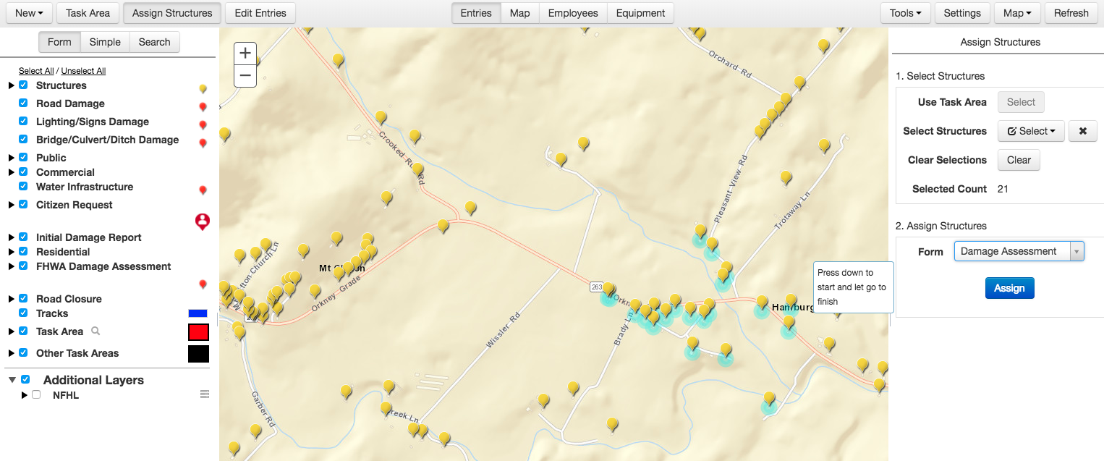
- Select the most appropriate form for the task and hit the Assign button.
- Once you have facilities selected, use the Assign button to assign the facilities to the Task.
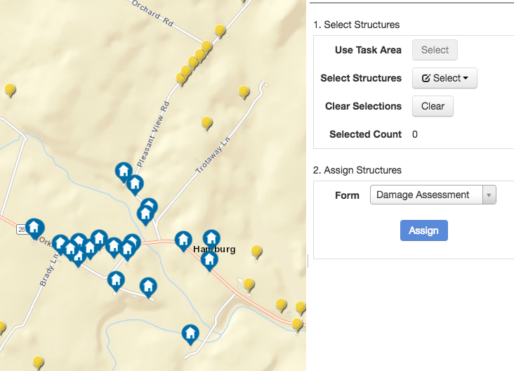
- By clicking on Assign, the structures selected will show up as Assignments for this Task. You have successfully assigned structures once the yellow pin drops have turned into blue building symbols.
- If you want to only select one address or if you want to zoom to an address, click on Tools then Address Search and type part of the address you want to select. The system will return several options and allow you to select or zoom to the address.
- If you do not want to select any structure, maybe the type of task does not require structure information such as debris estimation, then click on Tasks in the breadcrumb trail to return to the list of tasks.
Note: you can bulk edit the assignments by clicking the boxes on the left-hand side of the page and using the edit drop-down button in the top right-hand corner.
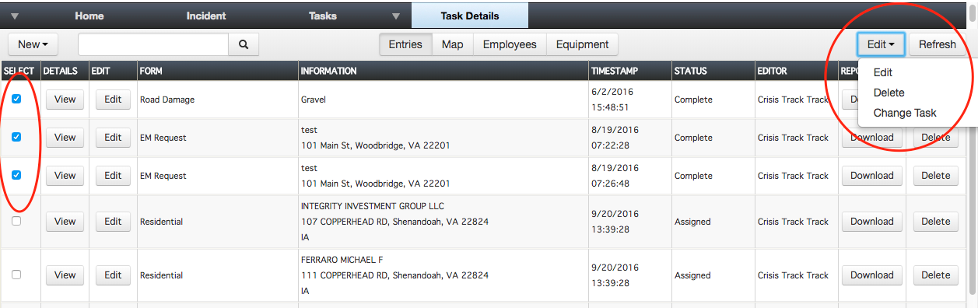

3.3.8 Conducting Damage Assessment Field Operations

3.3.8.1 Damage Assessment Team Pre-Deployment Briefing
Before conducting operations, the Damage Assessment Officer will conduct a Pre-Deployment Briefing to all members of the damage assessment teams. The Pre-Deployment Briefing should address:
    - Overview of Disaster Operations Current Situation Report
    - Known critical facilities
    - Codes and standards (FEMA Damage Categories)
    - Reporting requirements and priorities
    - Crisis Track Mobile App Quick Start Guide
    - Assign each member to a Team and Assign a Team Leader
    - Public and media contact procedures
    - Safety requirements
    - Routine communication check-ins
    - Debriefing time and location

The Damage Assessment Officer will also review the equipment for each team (see Appendix D).

3.3.8.2 Field Data Collection

Once the Teams are briefed, each Team Leader should Login using the Crisis Track mobile application. The Crisis Track mobile application differs from the console web application in that data can be collected without Internet connectivity. The Crisis Track mobile application is currently available for free on the Google Play Store, the Apple iTunes Store, and the Windows App Store. Each app has the same functionality listed below, although the look and feel may differ by mobile platform.
3.3.8.2.1 Selecting the Incident
The incidents that appear on the screen are those incidents that are marked “Active” in the list of Incidents from the Admin Console (see Section 3.3.2). The Team Leader should select the incident where the damage assessment data will be reported.
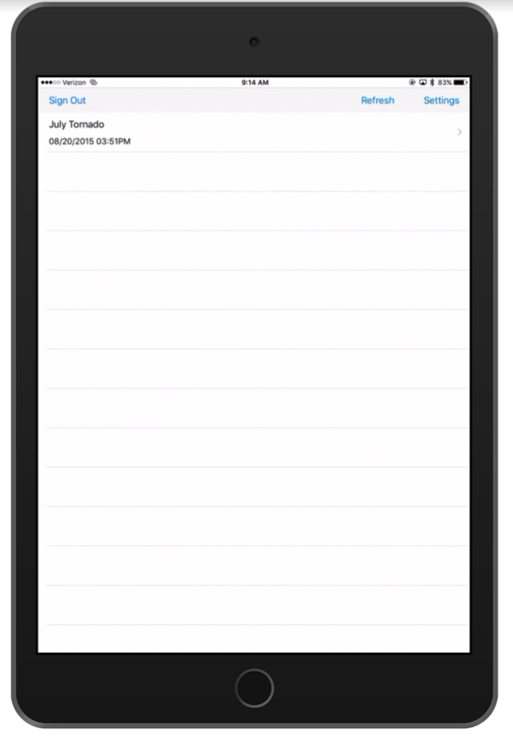
3.3.8.2.2 Collect Data – The Team Leader will then click on Collect Data. The Incident Map button on this screen will allow the Team Leader to see all completed entries and task areas for all teams.
3.3.8.2.3 Selecting the Team – The Team Leader will then select the correct team he or she belongs to. The Team Leader can create a new team by tapping on the three bars in the top right-hand corner and selecting “Create Team.”
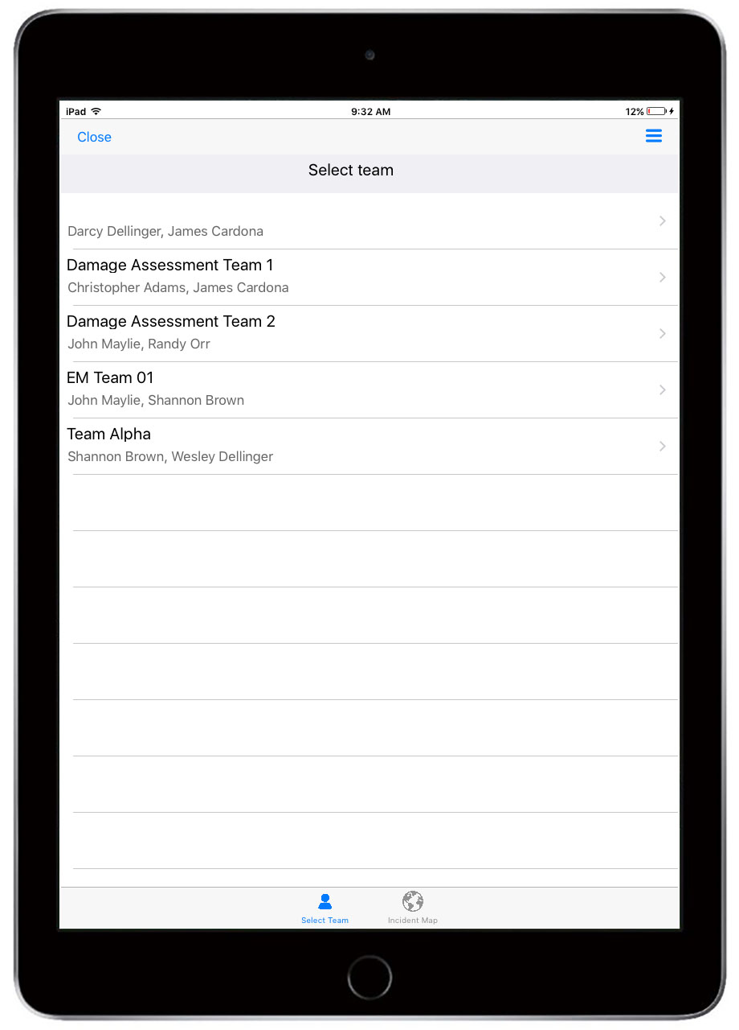
3.3.8.2.3 Selecting the Task – After the Team Leader selects the team, the app will show a list of tasks previously assigned to this team. The Team Leader can create a new task by clicking on the three blue bars in the top right-hand corner and selecting “Create Task.”
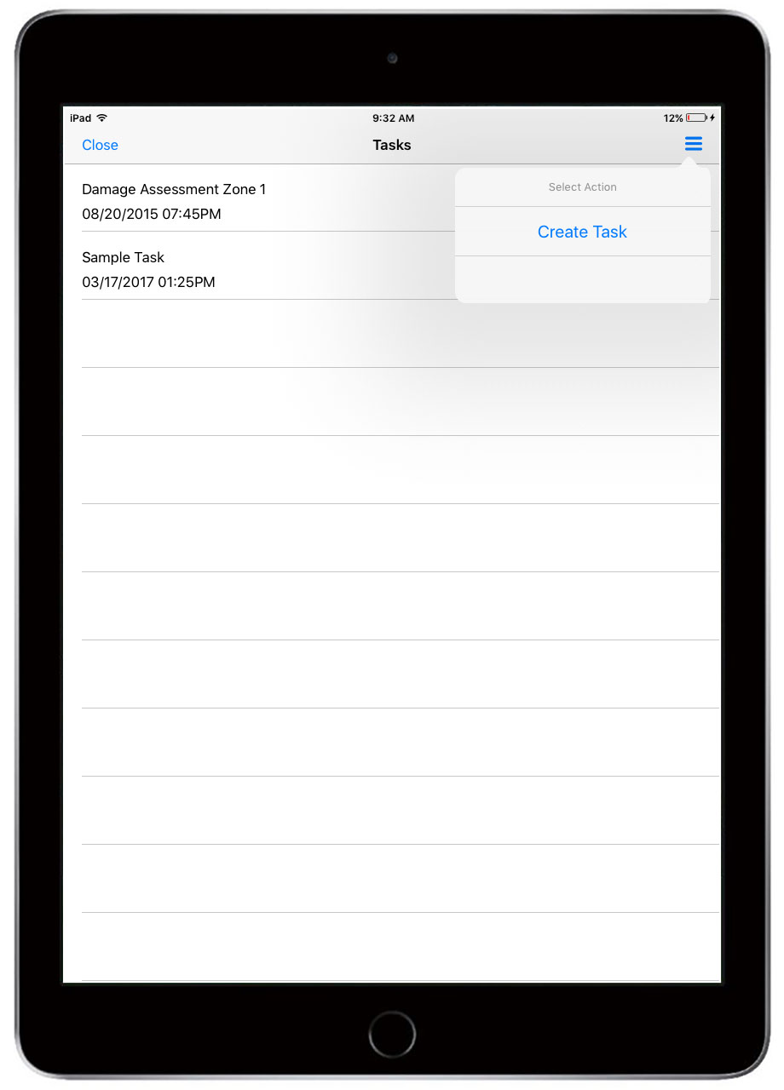
3.3.8.2.4 Clicking Start – Once the Team Leader selects the Task and clicks Continue (or Next), the Start Timer will appear. After clicking Start, the app will begin tracking the time and the location of the device.
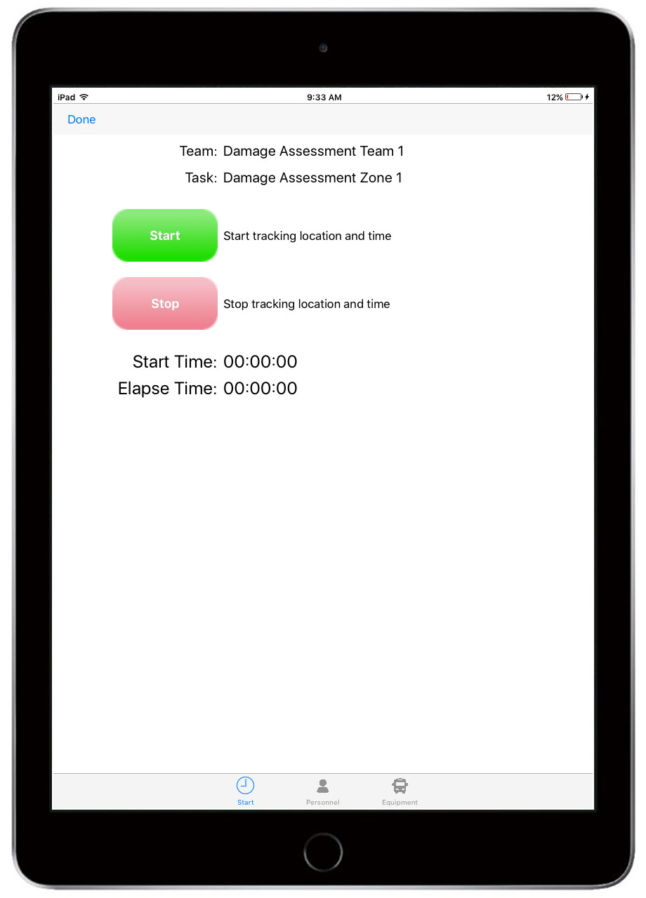
Note: To prevent connectivity issues in the field, teams should log into Crisis Track, select a Team, select a Task, and hit Start before going into the field. This will download all assessment assignment onto the device and start tracking the team’s time.

Personnel and Equipment can be edited by selecting the icons on the bottom of the screen from the Start/Stop page. Personnel and Equipment can be added or edited in the upper right-hand corner at this time.
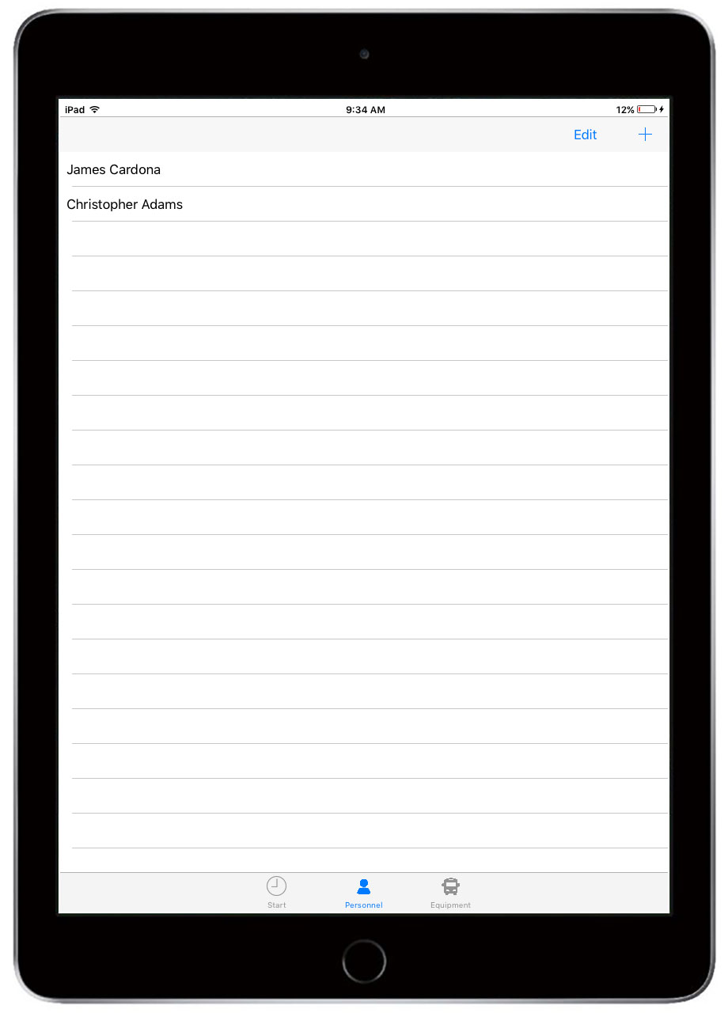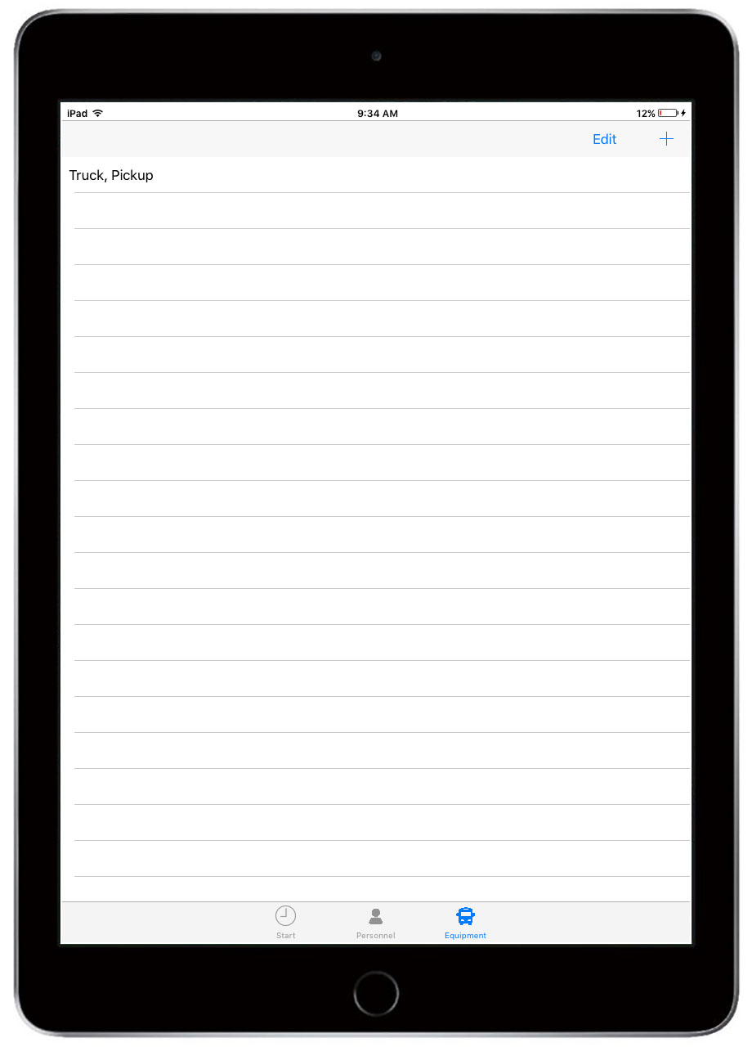
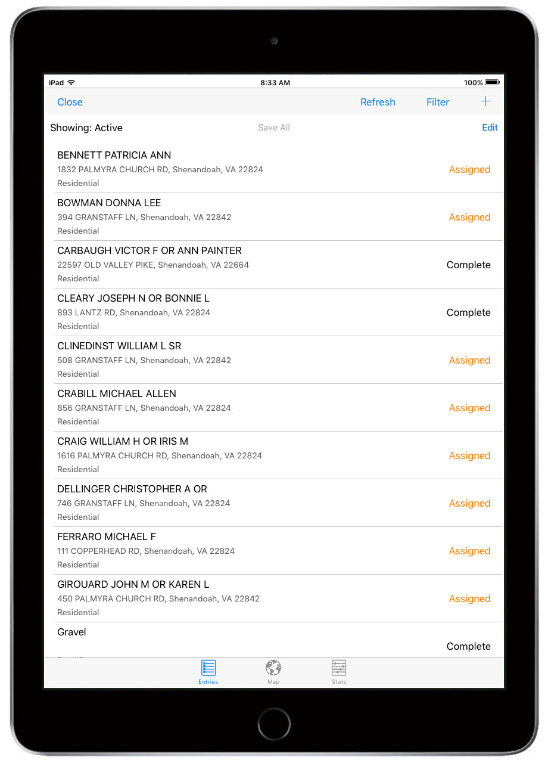
3.3.8.2.5 List and Map of Entries- After the Team Leader taps Start, a list of entries assigned to the task will appear. If no entries are assigned to the task, then the list will be empty. Using the Filter button, you can filter the list by entry status or sort the list by Name, Address, Street Name, proximity to your location, or edit time.
To view the entries on a map, tap the map button. The map background will default to any previously downloaded maps on the device (see Section 3.5.2.12). The Stats button to the right of the map button shows information about the entries, such as how many have been completed, as well as statistics about certain fields, like damage level.
3.3.8.2.6 Completing Assigned Entries – To select an assigned entry, the Team Leader either taps an entry from the list or taps a point on the map. This will return a partially completed form for the Team Leader to fill out.
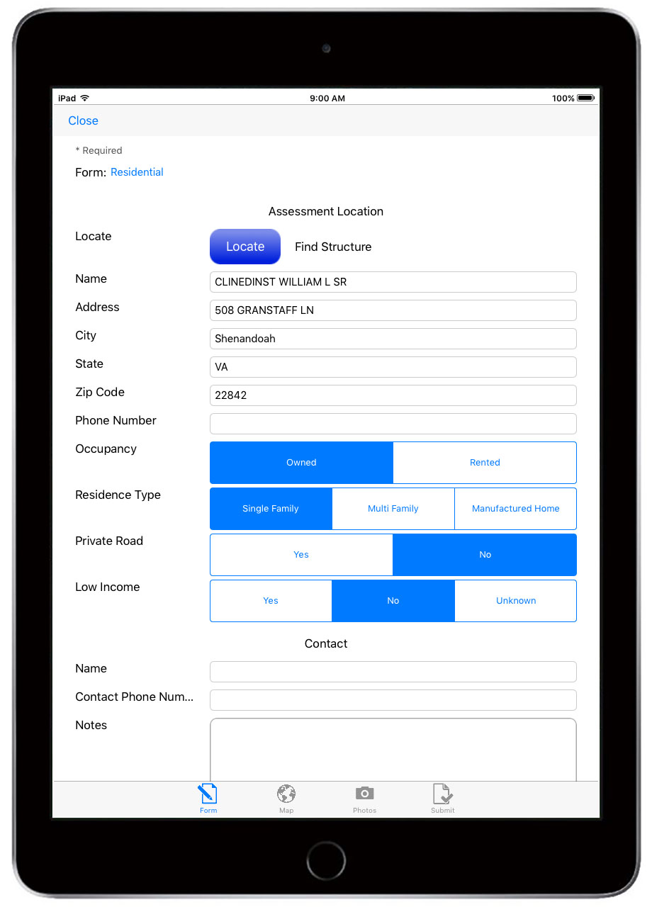

3.3.8.2.7 Switching Forms – If the form that shows up on an Assigned Entry is not the form type needed, the Team Leader can switch the form type by tapping on the Form Type listed on the form. For instance, if the pre-assigned entry form for a commercial building shows a residential damage assessment form, the Team Leader can click on “Residential” on the form to change the form type to “Commercial”. This will transfer all information over to the Commercial form.

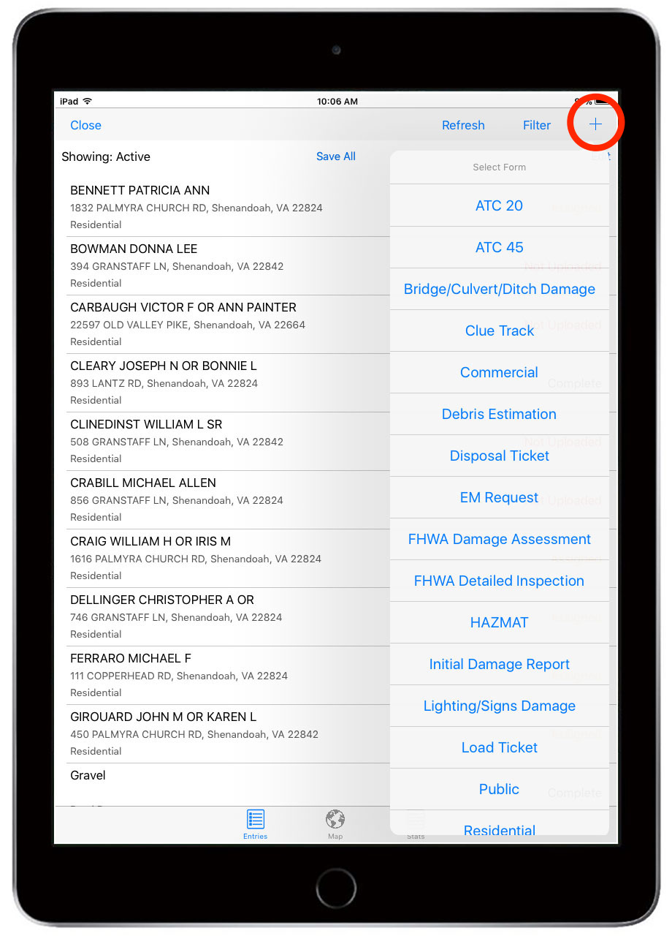
3.3.8.2.8 Completing a New Entry – when GIS data is missing or when a Damage Assessment Team sees a damaged structure that was not assigned to them but was in their Task Area, Crisis Track allows Teams to complete a blank damage assessment form.
To bring up a blank form, tap on the Plus Sign either on the map or the list view, then select a blank form you need to complete.
Please note: Unless you are able to identify the structure in the list of GIS Structures, the blank assessment will have no Structure Value and no Damage Value. These assessments will need to have values added from the console application.
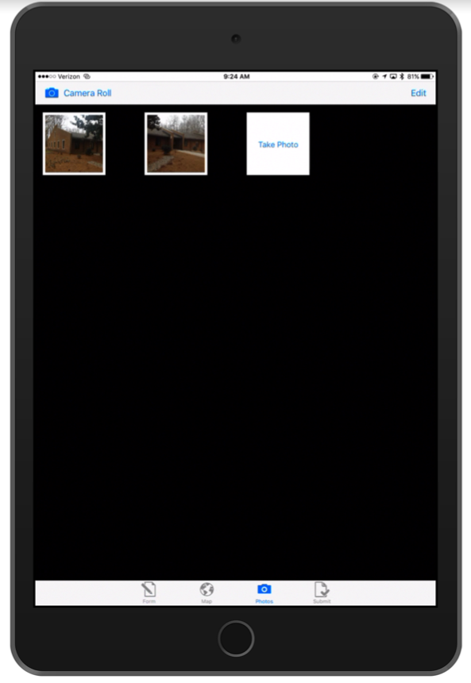

3.3.8.2.9 Taking Photos – The Camera Button will allow the Team Leader to take photos by activating the device’s camera. These photos will be associated with the Entry. To activate the camera, click on the Camera icon in the bottom panel and take a picture. The app will take the photo, orient the photo if necessary, compress the image, and return a thumbnail. Once the thumbnail shows on the screen, you can take another photo or delete the photo by tapping on Edit. Select Camera Roll if you want to select a previously taken photo that resides on the device.
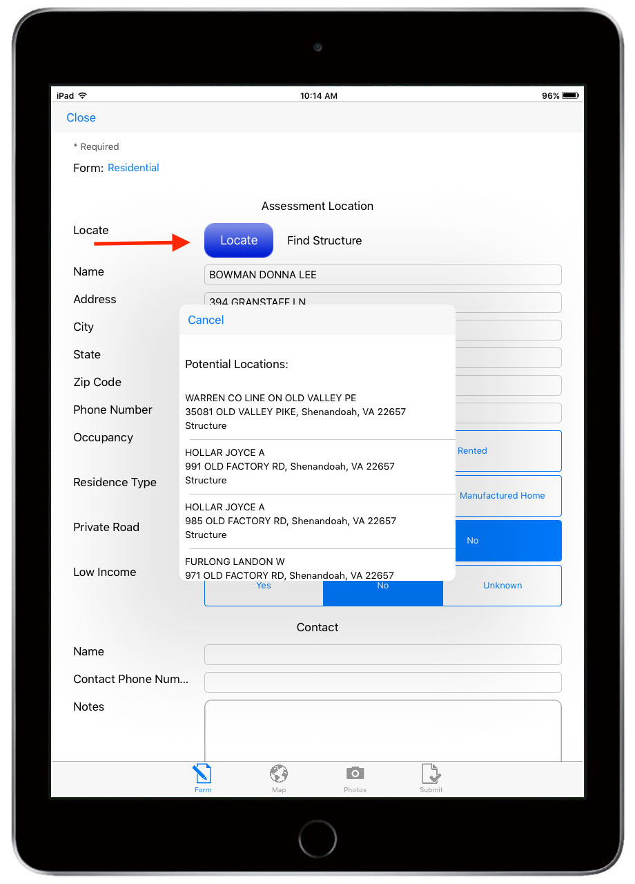
3.3.8.2.10 Moving or Adding an Entry Location – If the Team Leader needs to add a location to a form or change the location to an existing form, the Locate button will help add the point using the existing local address points. Once the button is clicked, the app will return the 10 closest addresses. The last item on the list is a geocoded address based off of the latitude and longitude of where the individual is standing.
By selecting an address point, this will link the form to the addresses tax identification, critical for gathering tax value of structures.

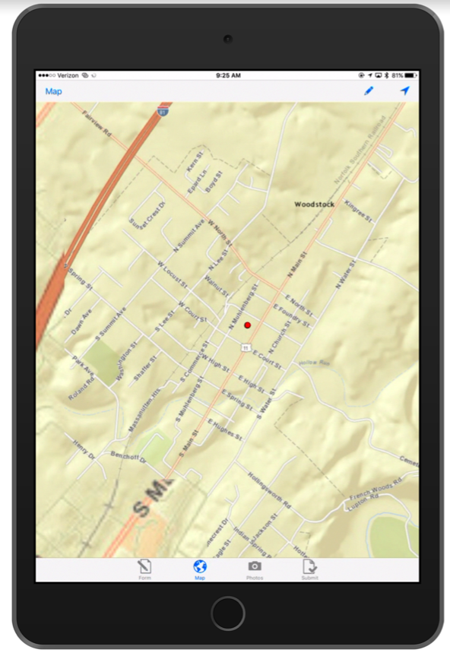
The Team Leader can also locate the structure using the Map icon on the form. When the map appears, click on the pencil once, then click on the map where you want to locate the structure. Here, the Entry’s location will change to the coordinates of the point on the map.

3.3.8.2.11 Saving an Entry – After completing the form and adding photos, the Team Leader can save the Entry by tapping on Submit on the bottom panel. This will return a Review screen showing all of the data associated with that Entry. With the iOS app, the save button will be visible all the time.
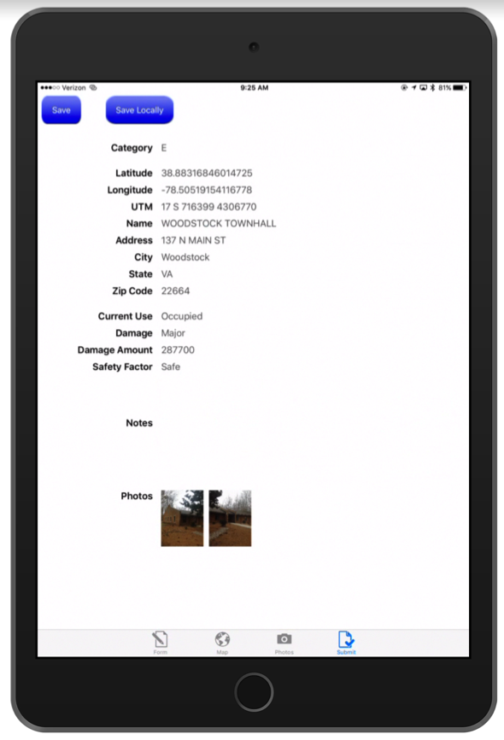
To save the Entry to the system, tap Save/Upload. The app will attempt to save the Entry to the Crisis Track servers if Internet connectivity is available. If Internet connectivity is not available, the app will save the data locally onto the device or provide a warning message to hit Save Locally.
If the Team Leader wants to save the entry to the devices without saving it to the Crisis Track servers, tap Save Locally.
If the Team Leader needs to add or change data to a completed entry, just click on that entry and make changes. Any additional changes will be updated to that entry and tracked by the system.

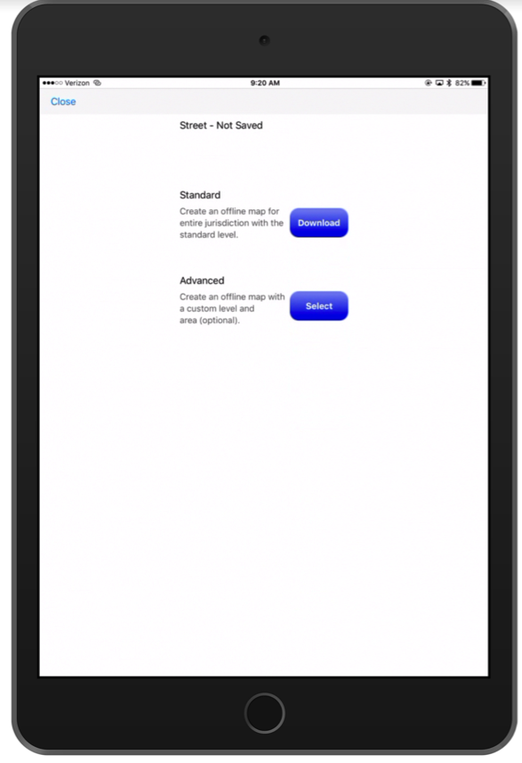
3.3.8.2.12 Conducting a Damage Assessment with Limited or No Internet Connectivity

When Damage Assessment Teams will expect limited or no Internet connectivity, there are a few steps that the Team Leader needs to perform to operate Crisis Track in a disconnected state.
1. Download Maps. After logging into the app select Settings in the upper right-hand corner. This is where the Team Leader can download basemaps for your jurisdictional area that will be visible in the Crisis Track app when there is no Internet connectivity.
To download a map, first tap the Settings button on the Incident screen after logging in. Then select the map type you want to download. There are two processes to download the map: standard and advanced.
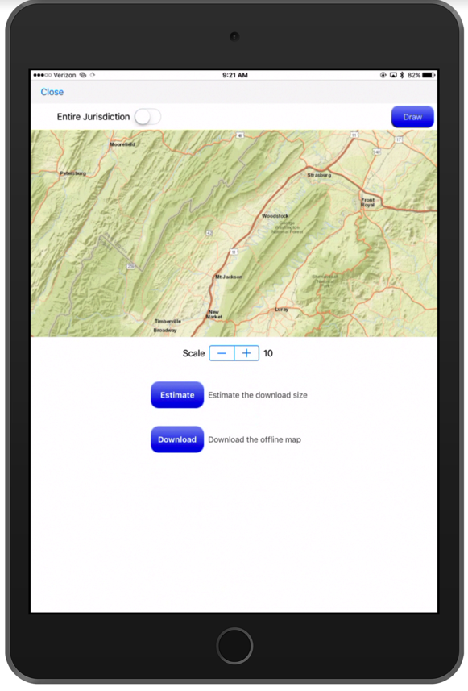
Downloading a Standard map will provide map tiles for the entire jurisdiction at a map scale dependent by the area (smaller jurisdictions will have greater resolution).
Selecting Advanced will allow you to set a specific resolution for the downloaded map as well as draw an area where the tiles are needed. By tapping on Estimate you can see how large the map download will be.

2

2. Download Structures. In addition to downloading the map backgrounds, teams should also download Offline Structures. This will allow the Locate button to work without Internet connectivity. Simply click on Offline Structure, then click Download.
3. Upload Assessments. Once the Damage Assessment Team reestablishes Internet connectivity, the Damage Assessment Team Leader can upload the assessment information collected. To upload data:
a. Navigate to the list of assignments on the Crisis Track mobile application. You will notice that some of the assessments may say “Not Uploaded.” These are the assessments that are not uploaded to the Crisis Track servers.
b. Click on Save All. This will upload all of the assessments that were not previously uploaded to the Crisis Track servers.
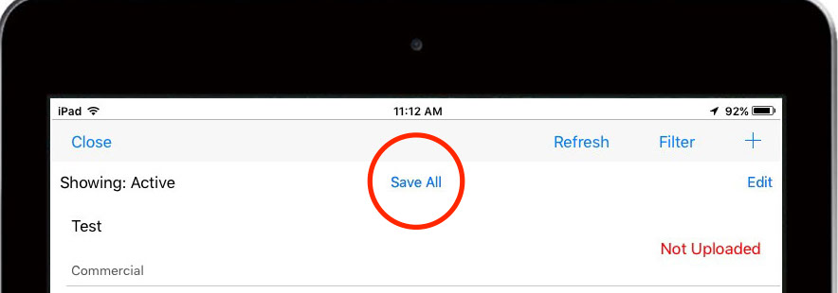

3.3.8.3 Conducting Damage Assessments from the Crisis Track Console App

Users can conduct a damage assessment either from the Crisis Track mobile application or the Crisis Track web application.
To conduct a damage assessment from the Crisis Track web application:
- Log into the Crisis Track Console by clicking:
https://www.crisistrack.com/console/
- Select the Disaster or Incident that you are working with.
- Then click on the Tasks icon in the Incident View:
- Click on View on the Task for which you want to assign structures
- Click on the Edit button for the structure you want to conduct an assessment on or click New.
- Edit the form as you would on the Crisis Track mobile application
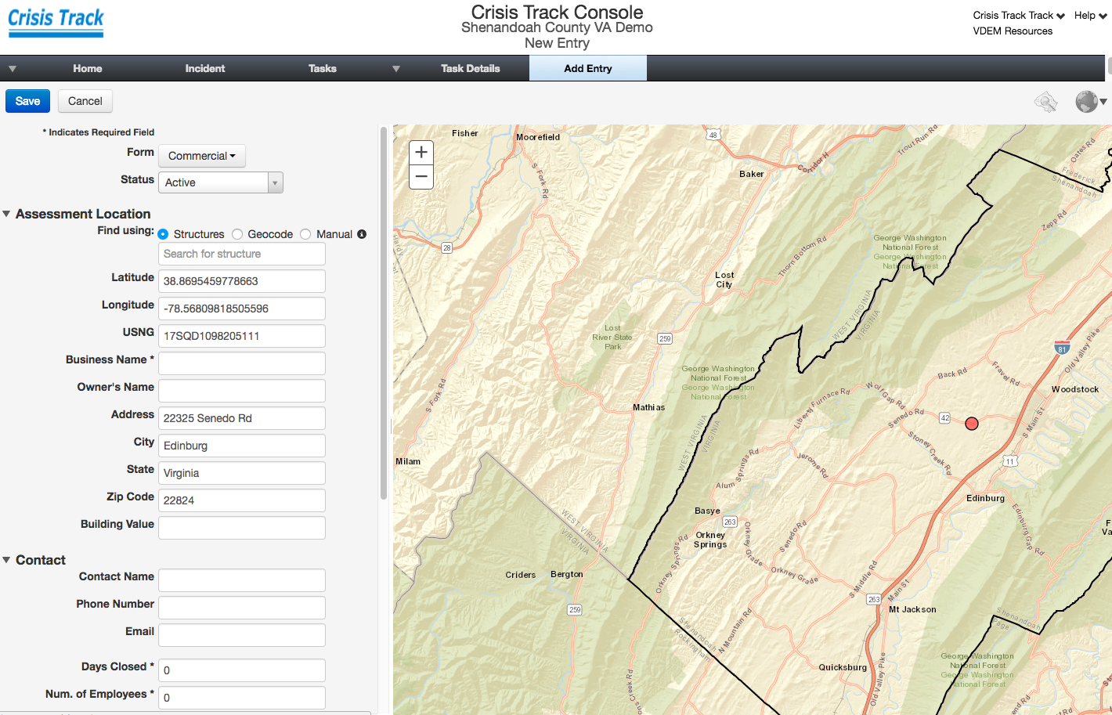

3.3.8.4 Initial Damage Reports and Citizen Self Reporting

Initial Damage Reports are a quick assessment to identify structures that have damage caused by the incident. Priority for a Rapid Damage Assessment is to roughly identify the extent and concentration of damage.
For more widespread events the Damage Assessment Officer may choose to organize Initial Damage Reporting teams to canvass neighborhoods for damage and use the Crisis Track Initial Damage Report Form to report damages. The procedure is similar to a detailed damage assessment.
In addition, Crisis Track can provide a Citizen Self Reporting web page where your constituents can complete a short initial damage reporting form. The data from this form is mapped to your Ops View.

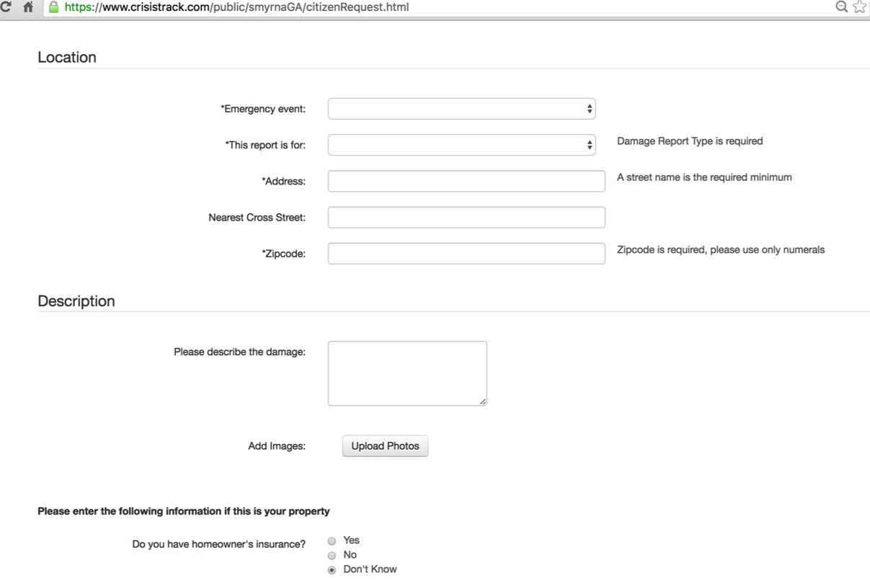

Using both the Initial Damage Reports and the Citizen Self Reporting forms can help the Damage Assessment Coordinator identify an Area of Concern and assign tasks to teams.

The Citizen Self Reporting website URL is:

https://www.crisistrack.com/public/<jurisdiction name><STATE INITIALS/citizenRequest.html

To enable the incident to show up on the list of incidents in the incident drop-down on the web form, click on your incident in the Crisis Track Admin module and make sure “Enable Citizen Request” is checked on.

To send email notifications when a citizen self report form is completed, open the Admin Console, click on Settings and click Edit. Here you can click on Notify and add a list of emails you would like the notification to be sent to.

3.3.9 Monitoring Tasks and Teams
In the Incident’s home screen the Operations View allows you to see incoming data and team locations real time.
To view your current operations
- Log into the Crisis Track Console by clicking:
https://www.crisistrack.com/console/
- Select an “Existing Incident” from the drop-down list and click Select.
- Click the Operations View button: 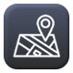

- You will see a map that shows each Team’s locations and data collect forms. Here’s an overview of the functionality for the Current Operations View:

From Ops View icon you can see where your teams have traveled and the assessments they completed. Uncompleted assessments will be blue and completed assessments will be green or shades of red depending on the damage category.

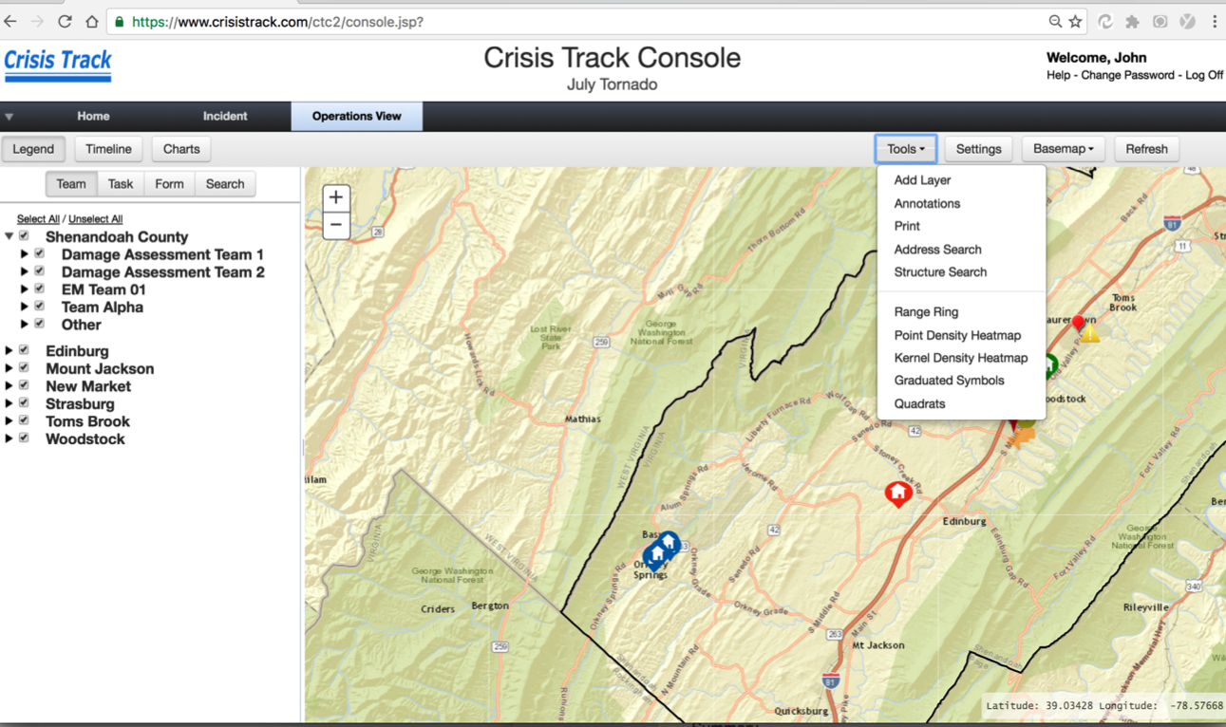

Clicking on the team name's arrow in the legend will reveal how the assessments are symbolized.

3.3.9.1 Legend Organization

There are 3 separate ways to organize the layers of your legend: by Teams, by Tasks, or by Forms.

Organizing your legend by Teams will allow you to focus on all data that each team collects regardless of task or form type.

Organizing your legend by Tasks will allow you to focus on all data for each task collects regardless of team or form type.

Organizing your legend by Form will allow you to focus on all data for each form type collects regardless of team or task.

Note layers with no entry form data will not be shown in the legend.

You can change the symbols of some layers of the map. To change colors on Tracks and Task Areas click on the symbol in the legend. This will pop up a color selector where you can change the color of the layer symbology. This change will only be made to the current session of your browser.

3.3.9.2 Timeline View
The Timeline button opens the time bars on the bottom of the screen to show when each team has logged in and has collected a form. You can change the view to be organized by day, week, month, or year. You can also search for a specific date on the timeline.
3.3.9.3 Charts
The Charts button will show summaries of your data collection operations. For disaster management the charts are organized by the different federal grant programs such as FEMA Public Assistance, FEMA Individual Assistance, and SBA Disaster Assistance. Hovering over any of the chart shapes will return actual values.

3.3.9.4 Tools
There are several tools available to help you analyze the data on the Ops View map. All analysis and map changes resulting from using the tools will only be save to the current session of your web browser.

Configure Layer – The Configure Layer tool will allow you to add GIS layers to your Ops View map. You can add a hosted Esri Map Service, Esri Feature Service, or Esri Web Map by entering the URL for the service. The National Flood Hazard Layer map (NFHL) is already included, but may need to be turned on by selecting the box on the left-hand panel under Additional Layers.
Annotations – The Annotations tool will allow you to draw points, lines, polygons, and text onto the Ops View Map.
Print - The Print tool will allow you to export an image of or print a simple map of the features on the Ops View map.
Address Search – The Address Search tool will find an address using a common geocoding service.
Structures Search – The Structures Search tool will find a structure location using your jurisdiction’s local GIS data. This search will most likely be more accurate that the Address Search.
Range Rings – The Range Rings tool will allow you to draw circles with an input radius in miles, kilometers, feet, or meters. First, enter your color, radius, units. Then click on the Draw button and click on the map location where you want the center of the circle. To draw concentric circles, just use the Range Ring tool multiple times and select the same location using different distances.
Point Density Heatmap - The Point Density Heatmap tool will create a surface representation of your data. This analysis is a good equal-weighted heatmap.
Kernel Density Heatmap – The Kernel Density Heatmap tool will also create a surface representation of your data. This analysis is good for identifying closely clustered point data.
Graduated Symbols – The Graduated Symbols tool uses a clustering algorithm to make a different sized circle depending on the number of data points in its close proximity.
Quadrats – The Quadrats tool will split data up into a grid and symbolize by the count in the grid.

3.3.6.2 Settings
Setting allows you to change the coordinate system and refresh rate of the map itself. Changing the coordinate system here (to either Lat/Long, USNG, or UTM) will change the coordinate values returned in the lower right hand corner when you move the cursor around the map. Changing the coordinate system value to none will remove the coordinate message from the map.

Clicking on Auto Refresh will allow the map to refresh at the time interval you select. Once this is set, you will not have to click on the Refresh button every time you want to see new data. By default, this feature is selected to “off.”

3.3.10 Damage Assessment Team Post Deployment Briefing
At the end of the Damage Assessment Operation, the Damage Assessment Officer will conduct a Post Deployment Briefing with the Damage Assessment Teams. The Post Deployment Briefing should consist of the following:
- Report the status of their assignments
- Report any contact with public or media
- Report problems with the equipment or software
- Identify any other issues or concerns

The Post Deployment Briefing notes will serve as the basis for any after action reporting.

3.3.11 Reporting
Information captured from the entry forms on the Crisis Track mobile applications auto-populate and export to standard FEMA and ICS forms. In Crisis Track, reports are called “Documents”. The Documents saved in a Crisis Track incident are snapshots of data collected at that particular time. In this way, you can save versions of documents as the incident progresses, say, for each operational period.
3.3.11.1 Detecting Duplicates
Before exporting any forms, it is a good idea to use our Detect Duplicates tool. Here’s how do it:
- Select your disaster or incident
- Select the Entries Icon 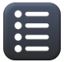
- In the top panel, click Duplicates, then Detect Duplicates.
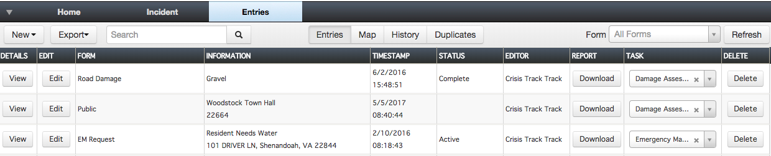
- A list of duplicates will appear and you can delete duplicates at this time.

3.3.11.2. Outputting Documents
When you are ready to output a report, from the Incident home page click on Documents and Add. This will present a list of all output reports available to you. Select the report you want, edit any details in the form, then click save. This will be a snapshot of the input data when you saved the report.
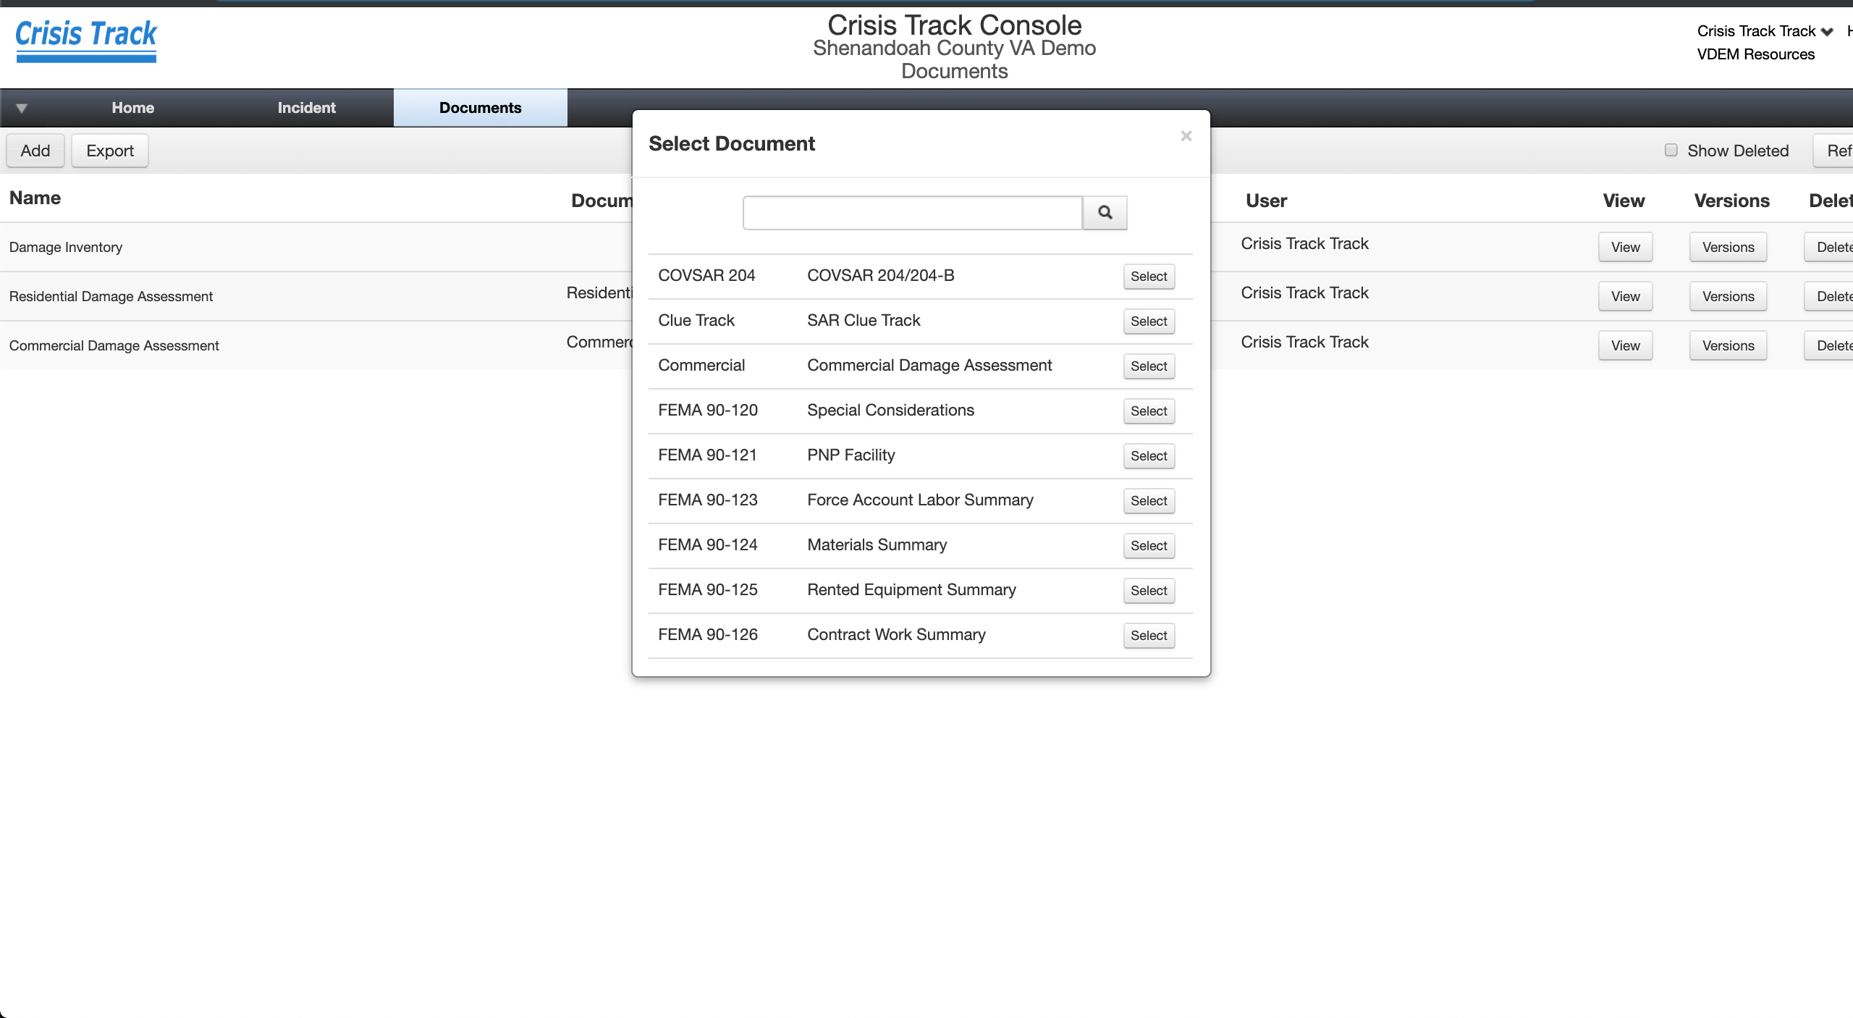
To print, either click View and Export on an individual report. Or click Export on the list of reports to get a zip file of all documents saved.

3.3.12 Subsequent Support Activities
To export the Assessment information into an Excel spreadsheet or an Esri Shapefile, click Incident in the title bar, and then click the Entries button. Click the Export button and select the format you desire.
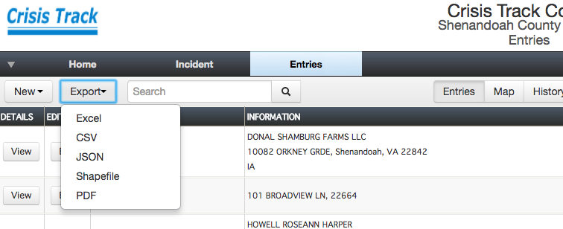

3.4 Maintenance of Procedures, Systems and Capabilities

Appendix A: Organizational Chart for Damage Assessment

Appendix B: List of Damage Assessment Teams

Appendix C: Roster of Trained Damage Assessment Personnel

Appendix D: Equipment and Supplies for a Damage Assessment Team

Suggested Equipment for Personal Protection
- Hard hat
- Long pants, long sleeve shirt
- Work boots (steel toed)
- Rubber boots
- Niosh N95 filter masks
- Leather work gloves
- Raincoat or poncho
- Safety Vest
- Flashlight with spare batteries
- Safety whistle
- Safety glasses
- Personal first aid kit
- Insect repellant
- Sunscreen
- Hand sanitizer
- Official identification, authorization letter or cards
- Bottled water

Damage Assessment Team-Issued Equipment
- Copy of this procedure
- Mobile Device with Crisis Track Application pre-loaded
- Radio, if necessary
- Multiple copies of IA and PA Damage Assessment Forms
- Mapbook of the Jurisdiction
- Digital camera with extra batteries and disks
- Tape measure
- Paper towels
- Paper, pencils, clipboards, etc.
- Calculator
- Emergency telephone listing of appropriate Jurisdiction officials

Appendix E: Quick Reference Guide for Crisis Track Structural Assessments

Appendix F: Damage Category Reference Guide

Appendix G: Standard Forms Used to Conduct Damage Assessment Operations

